**Steps**

Grand step 1 (two process) is on server 1 (**publisher**).

Grand step 2 is on server 2 (**subscriber**).

**Grand step 1**

**Create Distributor (configure distribution)**

1

Begin with replication on the SSMS

Choose the server either to be a publisher or distributor to other publisher

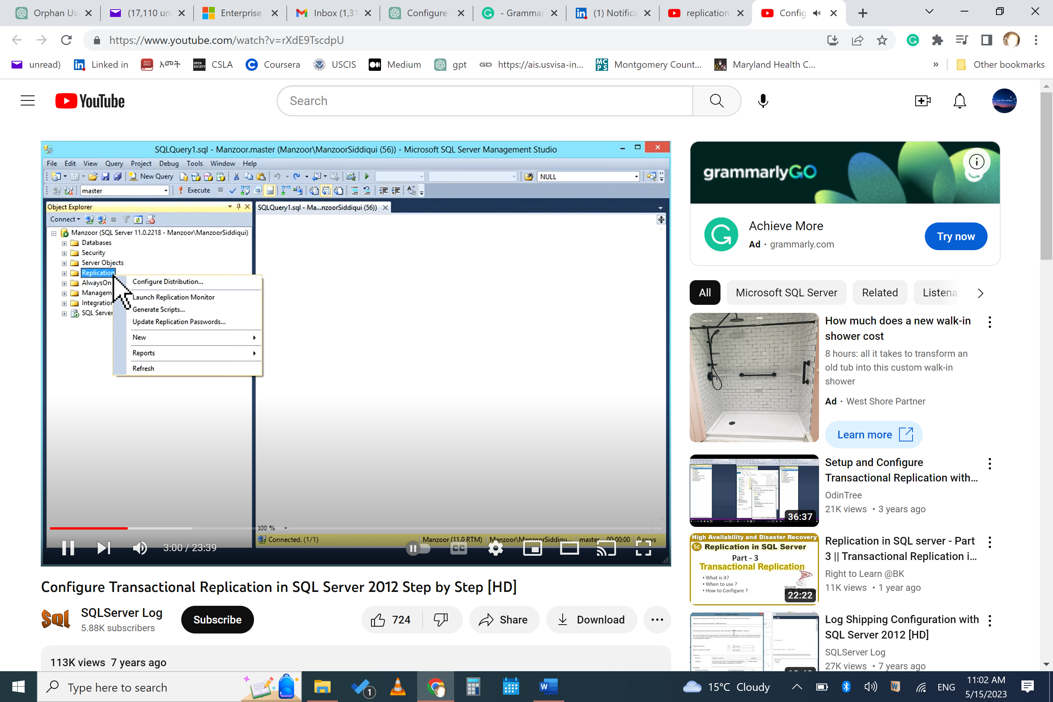 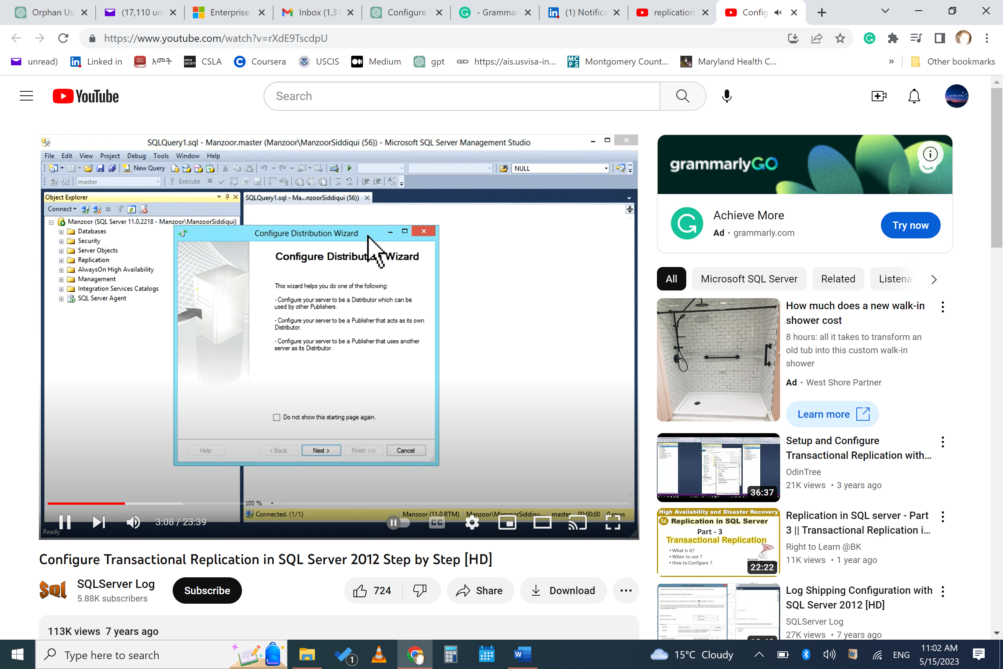

2

You can choose the default distributor (own distributor) otherwise choose another instance as distributor.

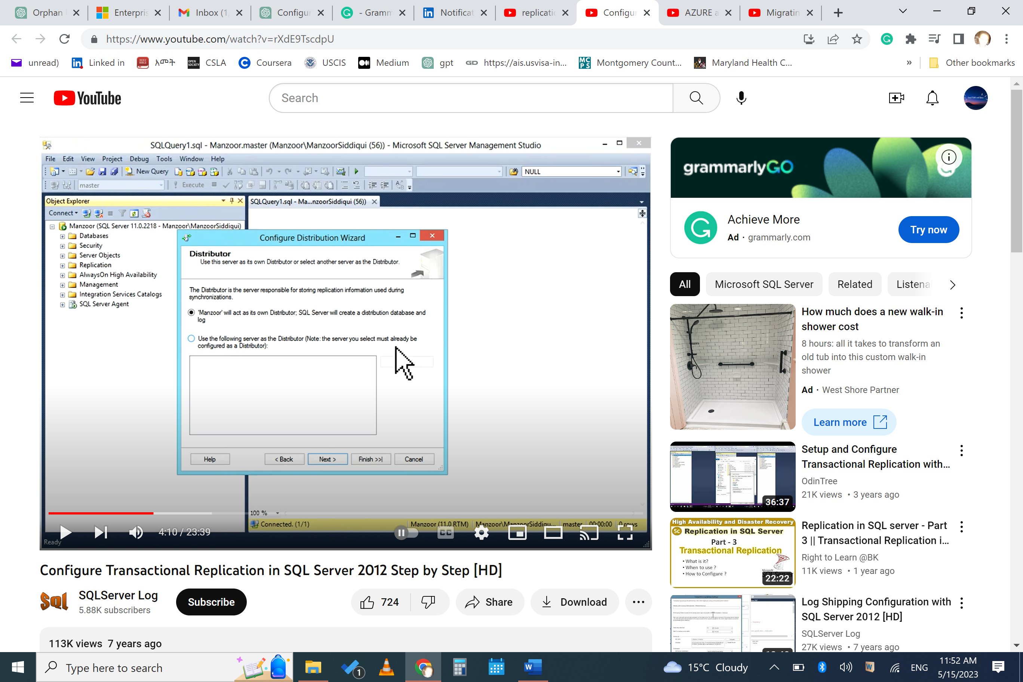

3

Define path. Choose default (if using own distributor), or set a shared path if the distributor is different server.

4.

Distribution database name and mdf-log file path (you can leave default)

5.

**Publisher** (it will enable the distributer when it became publisher)

Select by default. You can add publishers with “ADD”

6.

Wizard or script?

7.

Verify steps and finish

….

**On the same instance/server**

**Create Publisher (replication – new – publication)**

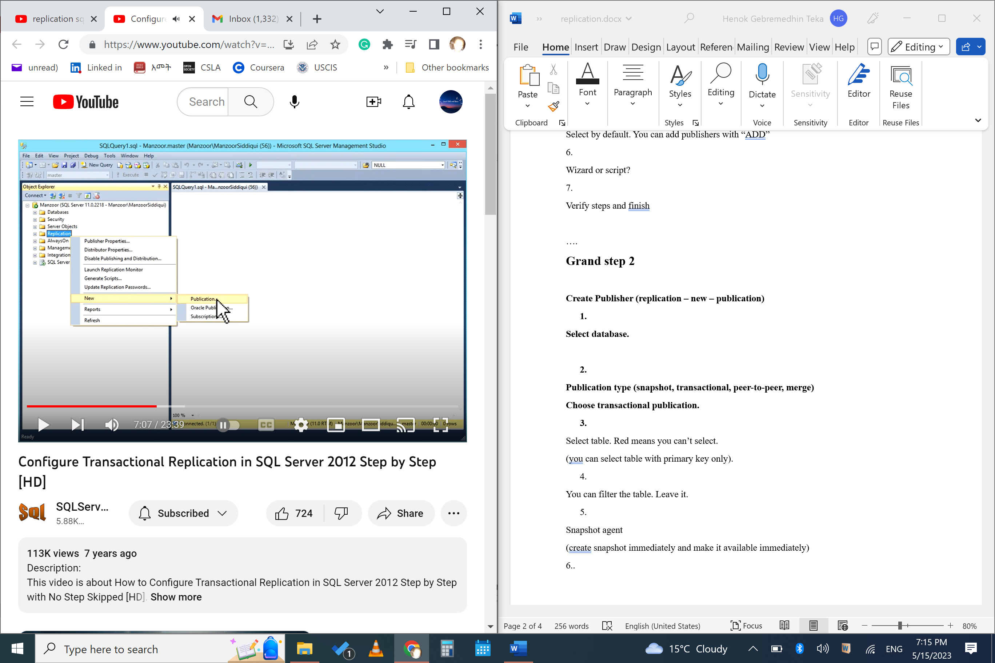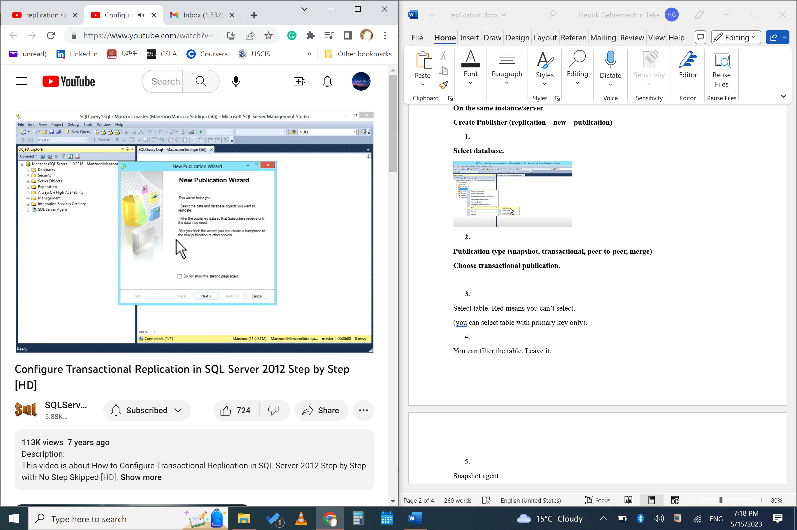

**Select database.**

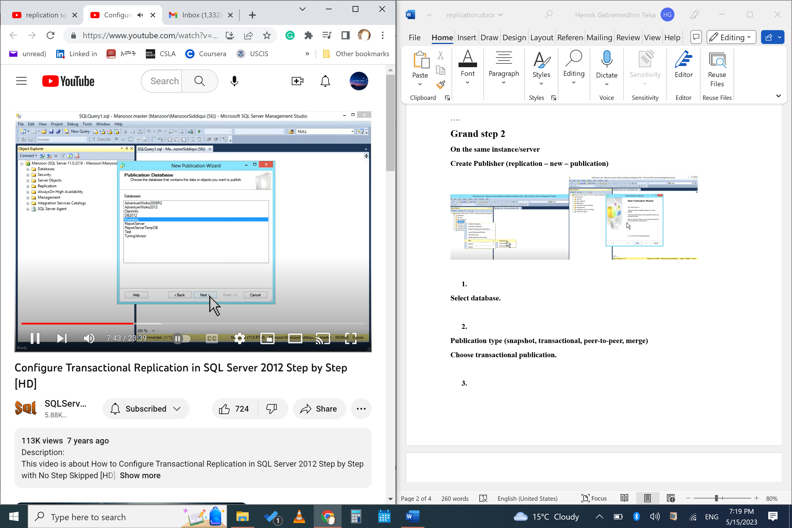

**Publication type (snapshot, transactional, peer-to-peer, merge)**

**Choose transactional publication.**

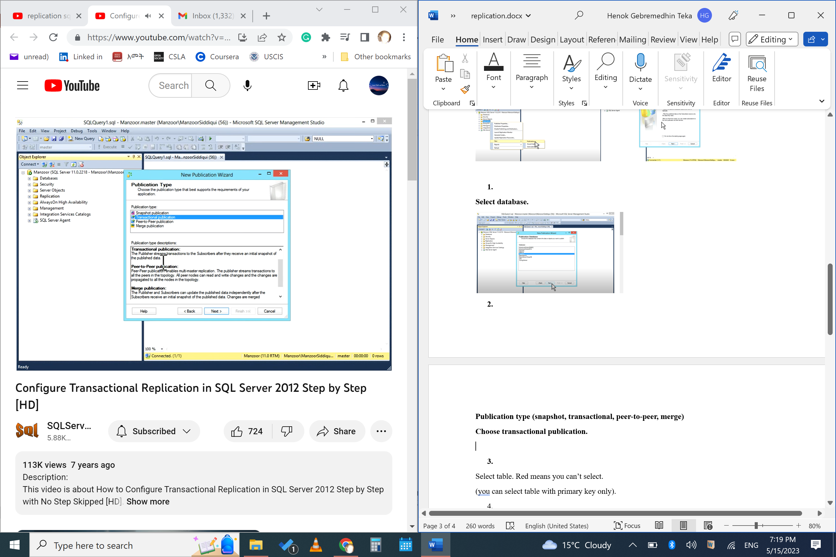

Select table. Red means you can’t select.

(you can select table with primary key only).

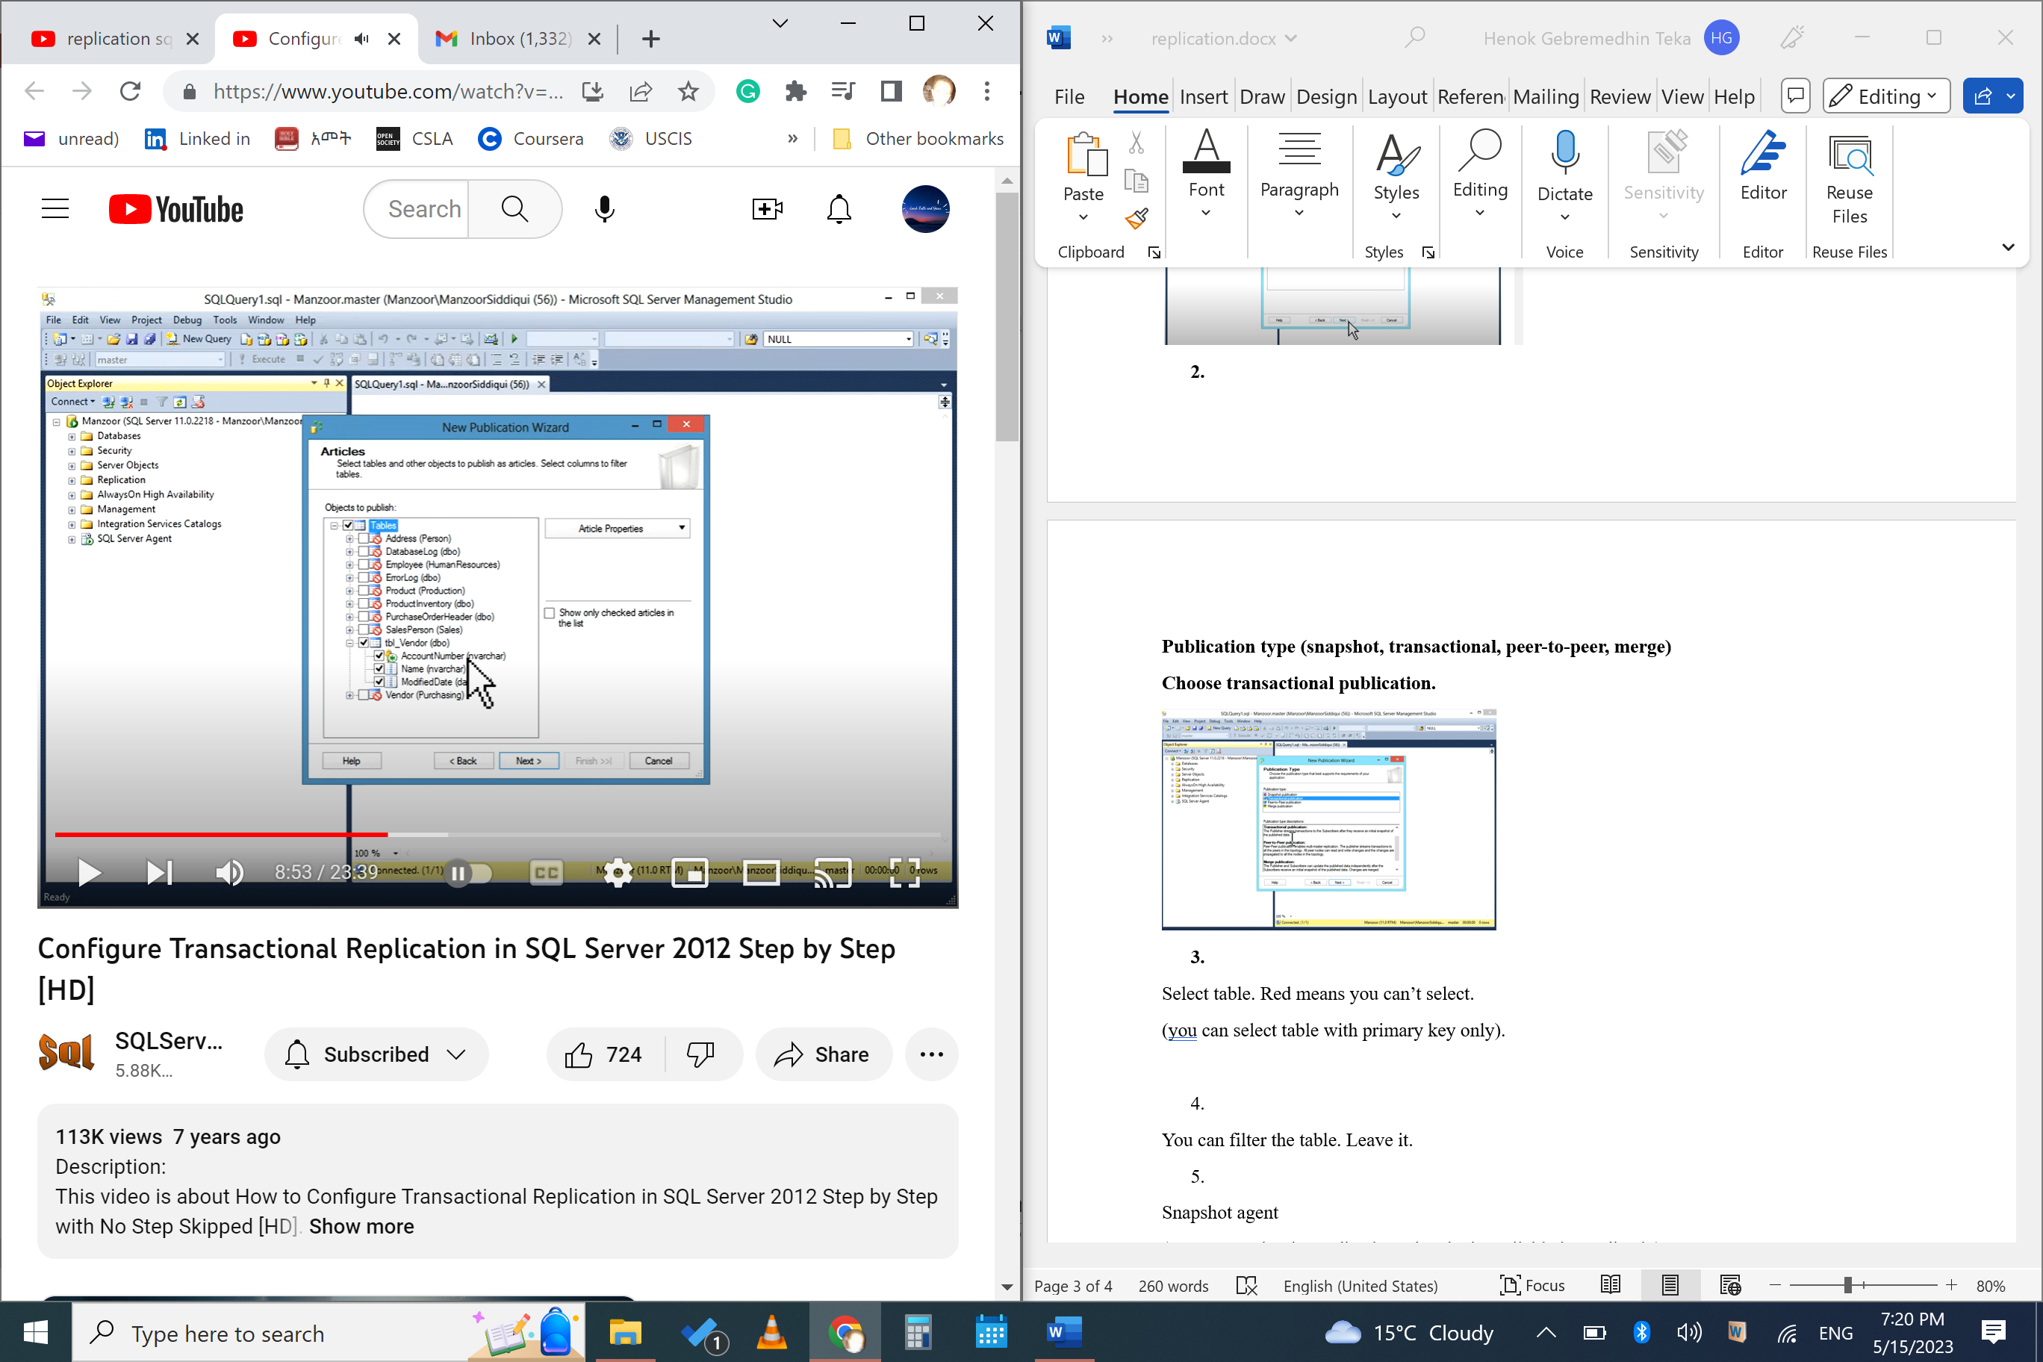

You can filter the table. Leave it. ADD if you want – select table – select and filter columns.

**Snapshot agent**

(create snapshot immediately and make it available immediately)

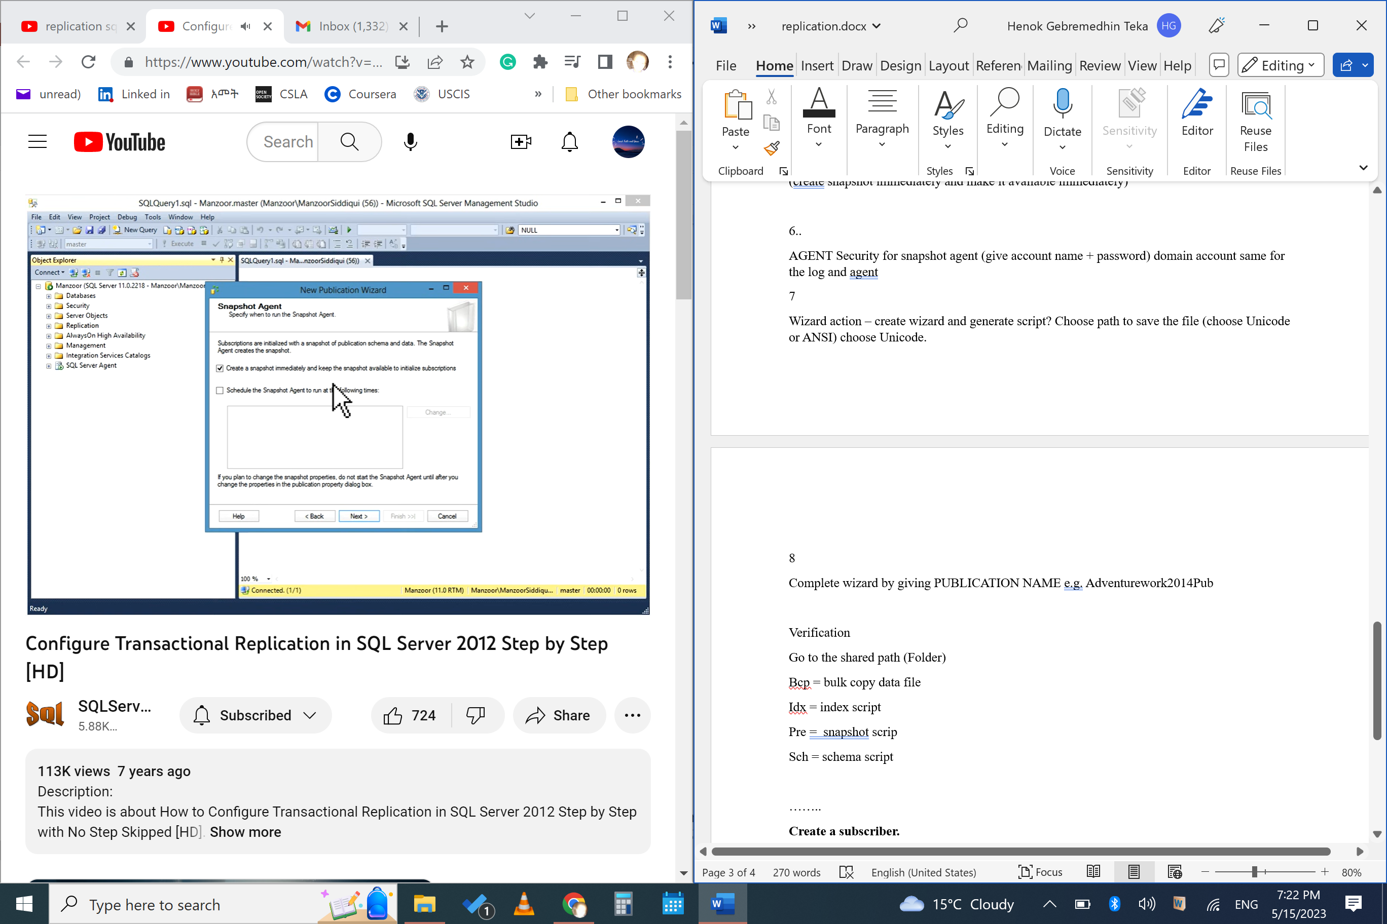

6..

AGENT Security for snapshot agent (give account name + password) domain account same for the log and agent (right is by default selected_

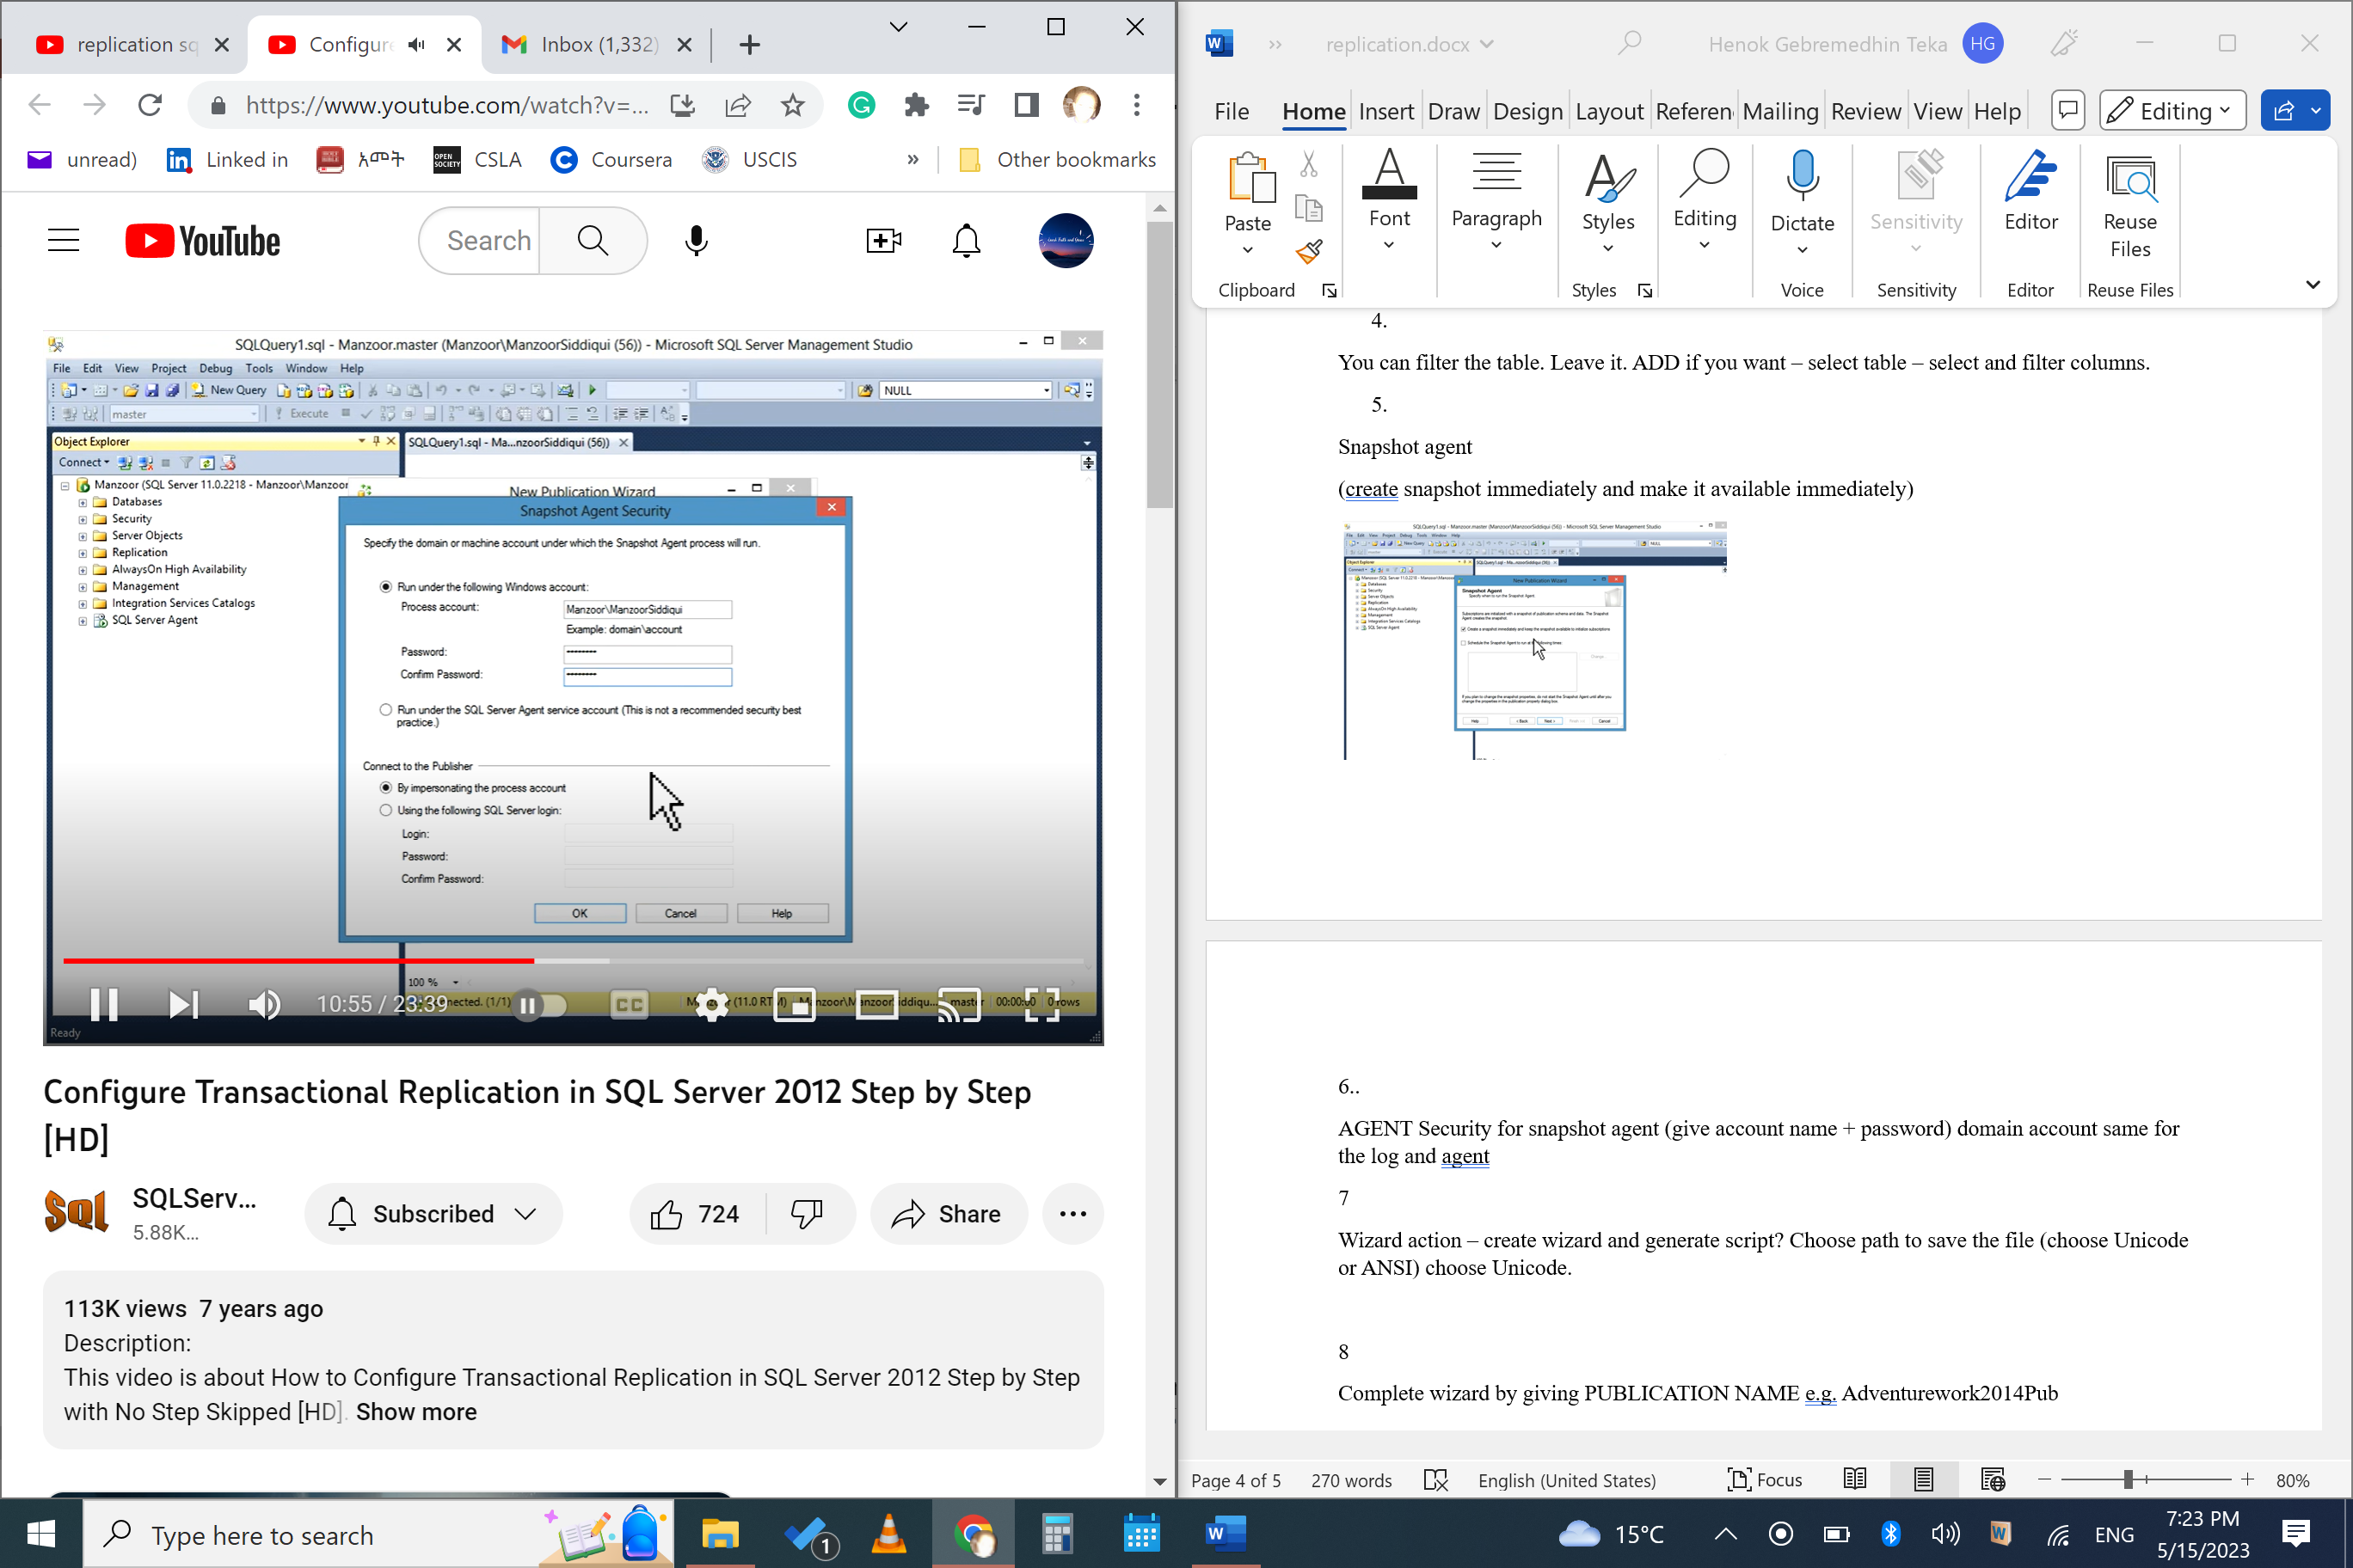 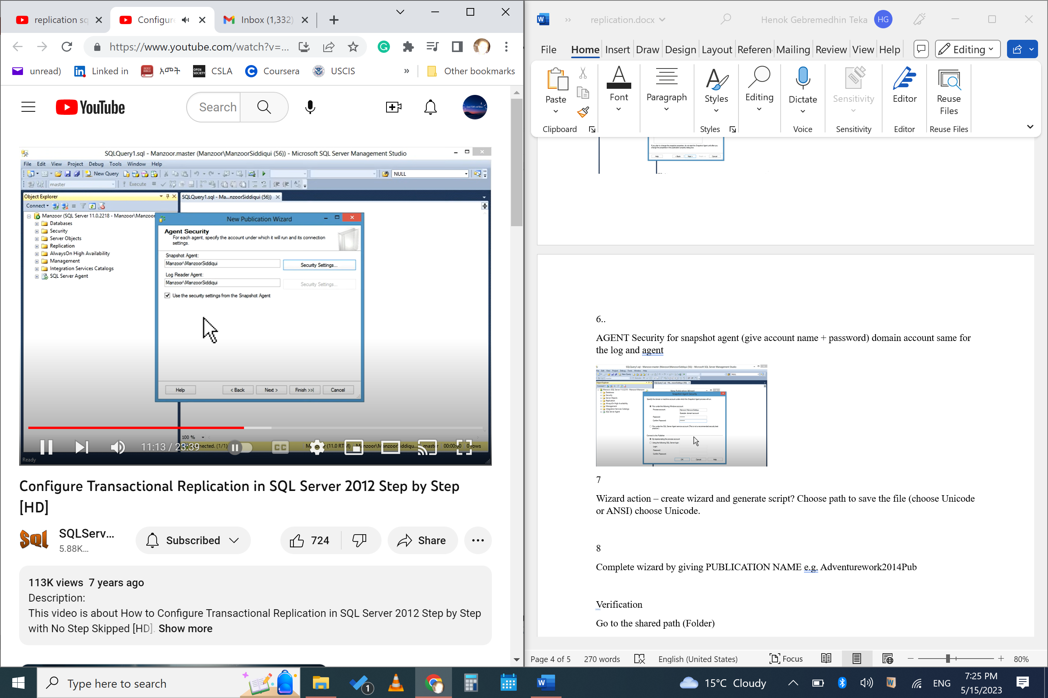

7

Wizard action – create wizard and generate script? Choose path to save the file (choose Unicode or ANSI) choose Unicode.

8

Complete wizard by giving PUBLICATION NAME e.g. Adventurework2014Pub

Verification

Go to the shared path (Folder). File types

Bcp = bulk copy data file

Idx = index script

Pre = snapshot scrip

Sch = schema script

……..

**Grand step 2**

**Create a subscriber. One or more publisher is possible.**

Step 1

Replication – new – subscription

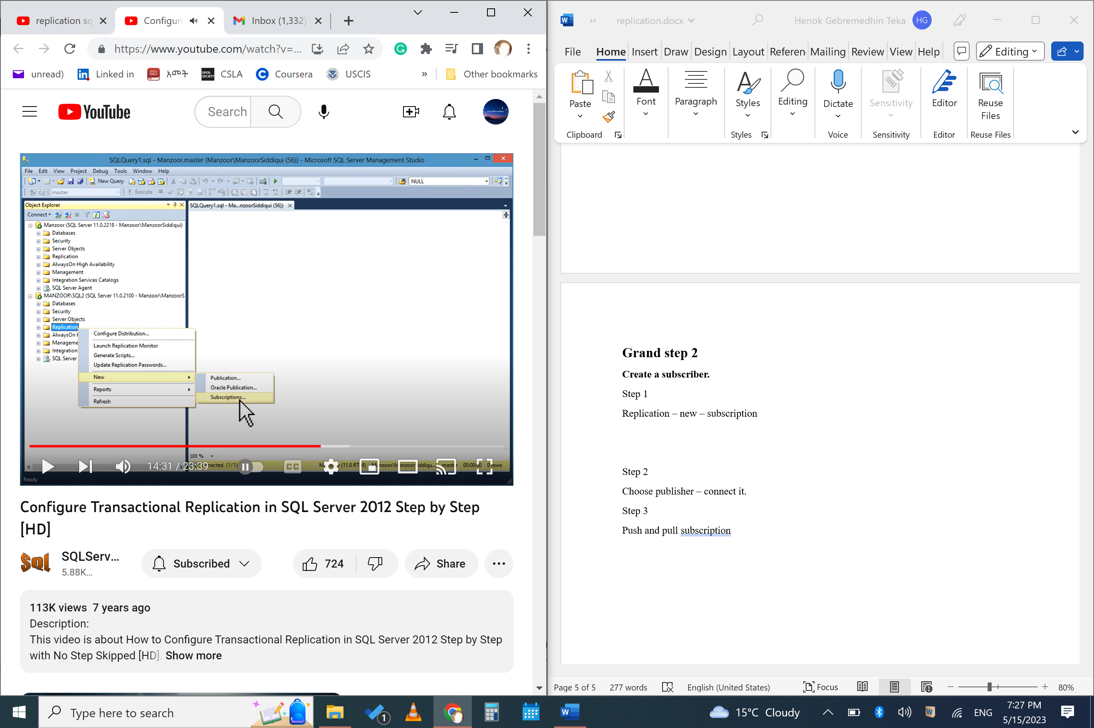

Step 2

Choose publisher – connect it.

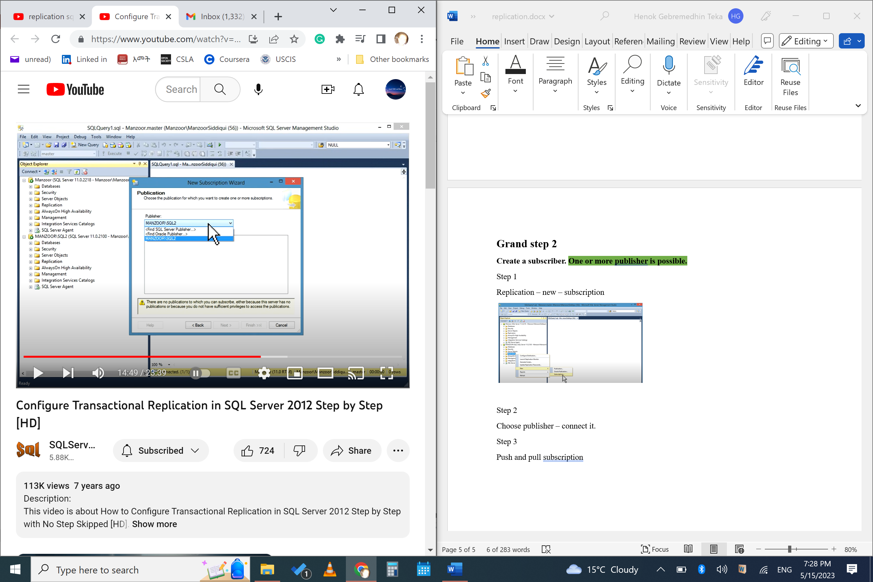

Step 3

Push and pull subscription. Choose default

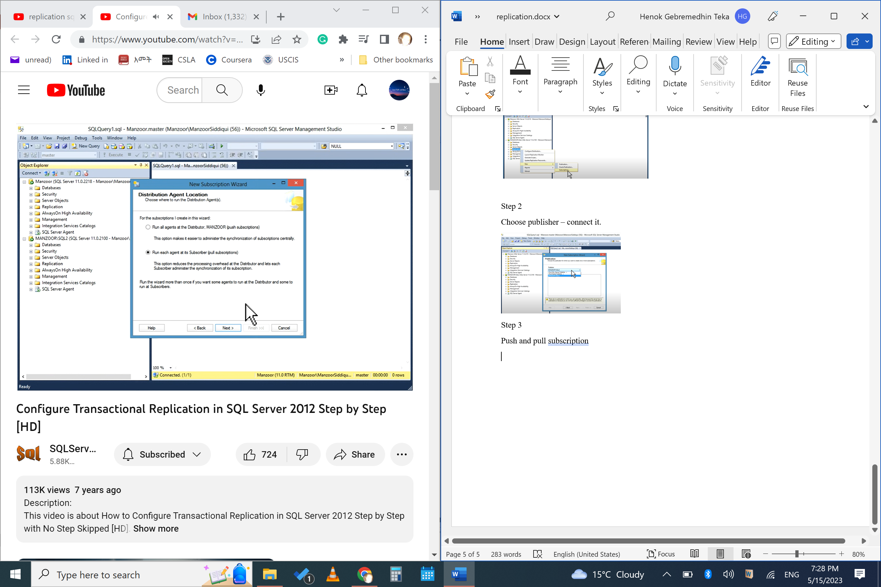

Step 4

Subscription database. Choose if you created or create new database (add).

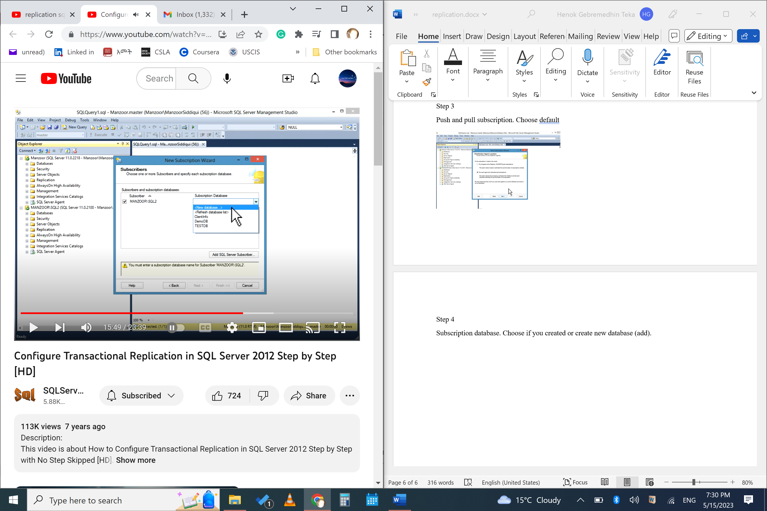

Stepp 5

Distribution Agent security. Click (---) new wizard pop-up (right

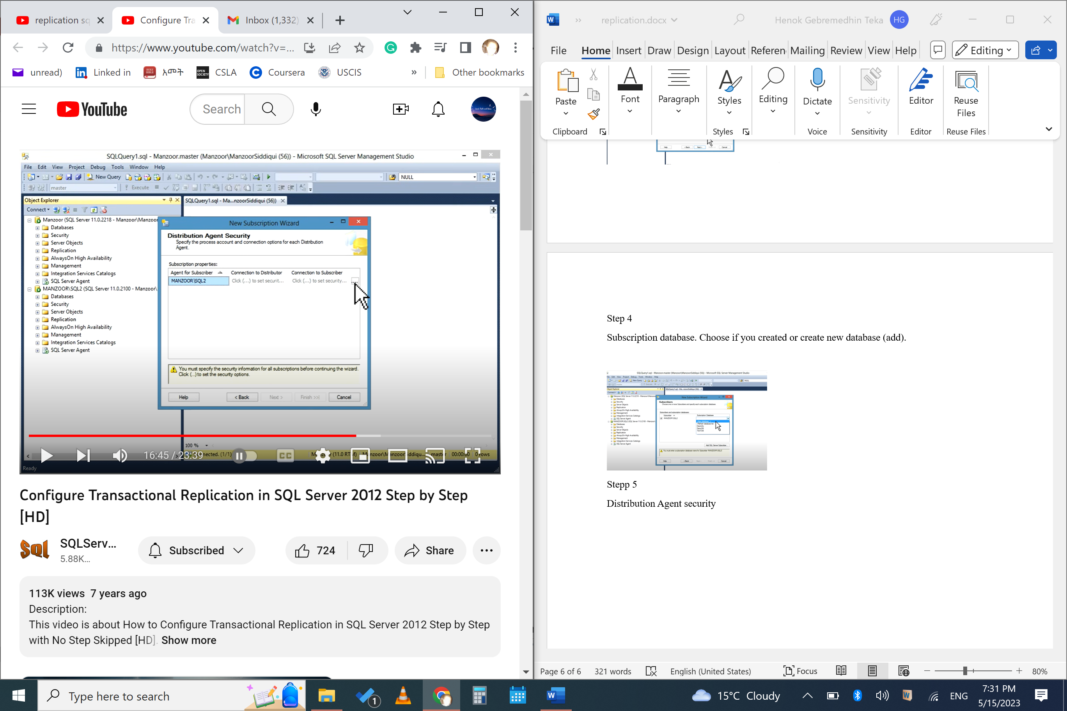 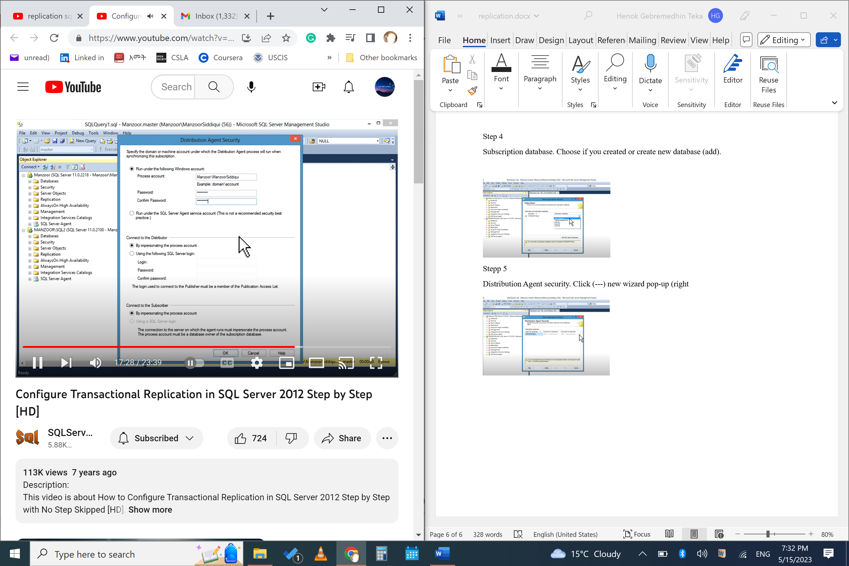

Step 6

Synchronization schedule

**Agent schedule**: run immediately or on demand. Choose immediately for demo

Step 7

Initialize subscriptions

**Initialize when**: immediately

Step 8

Wizard action. Create script or not. FINISH.

**Verification.**

**Replication Monitor** On primary (publisher)

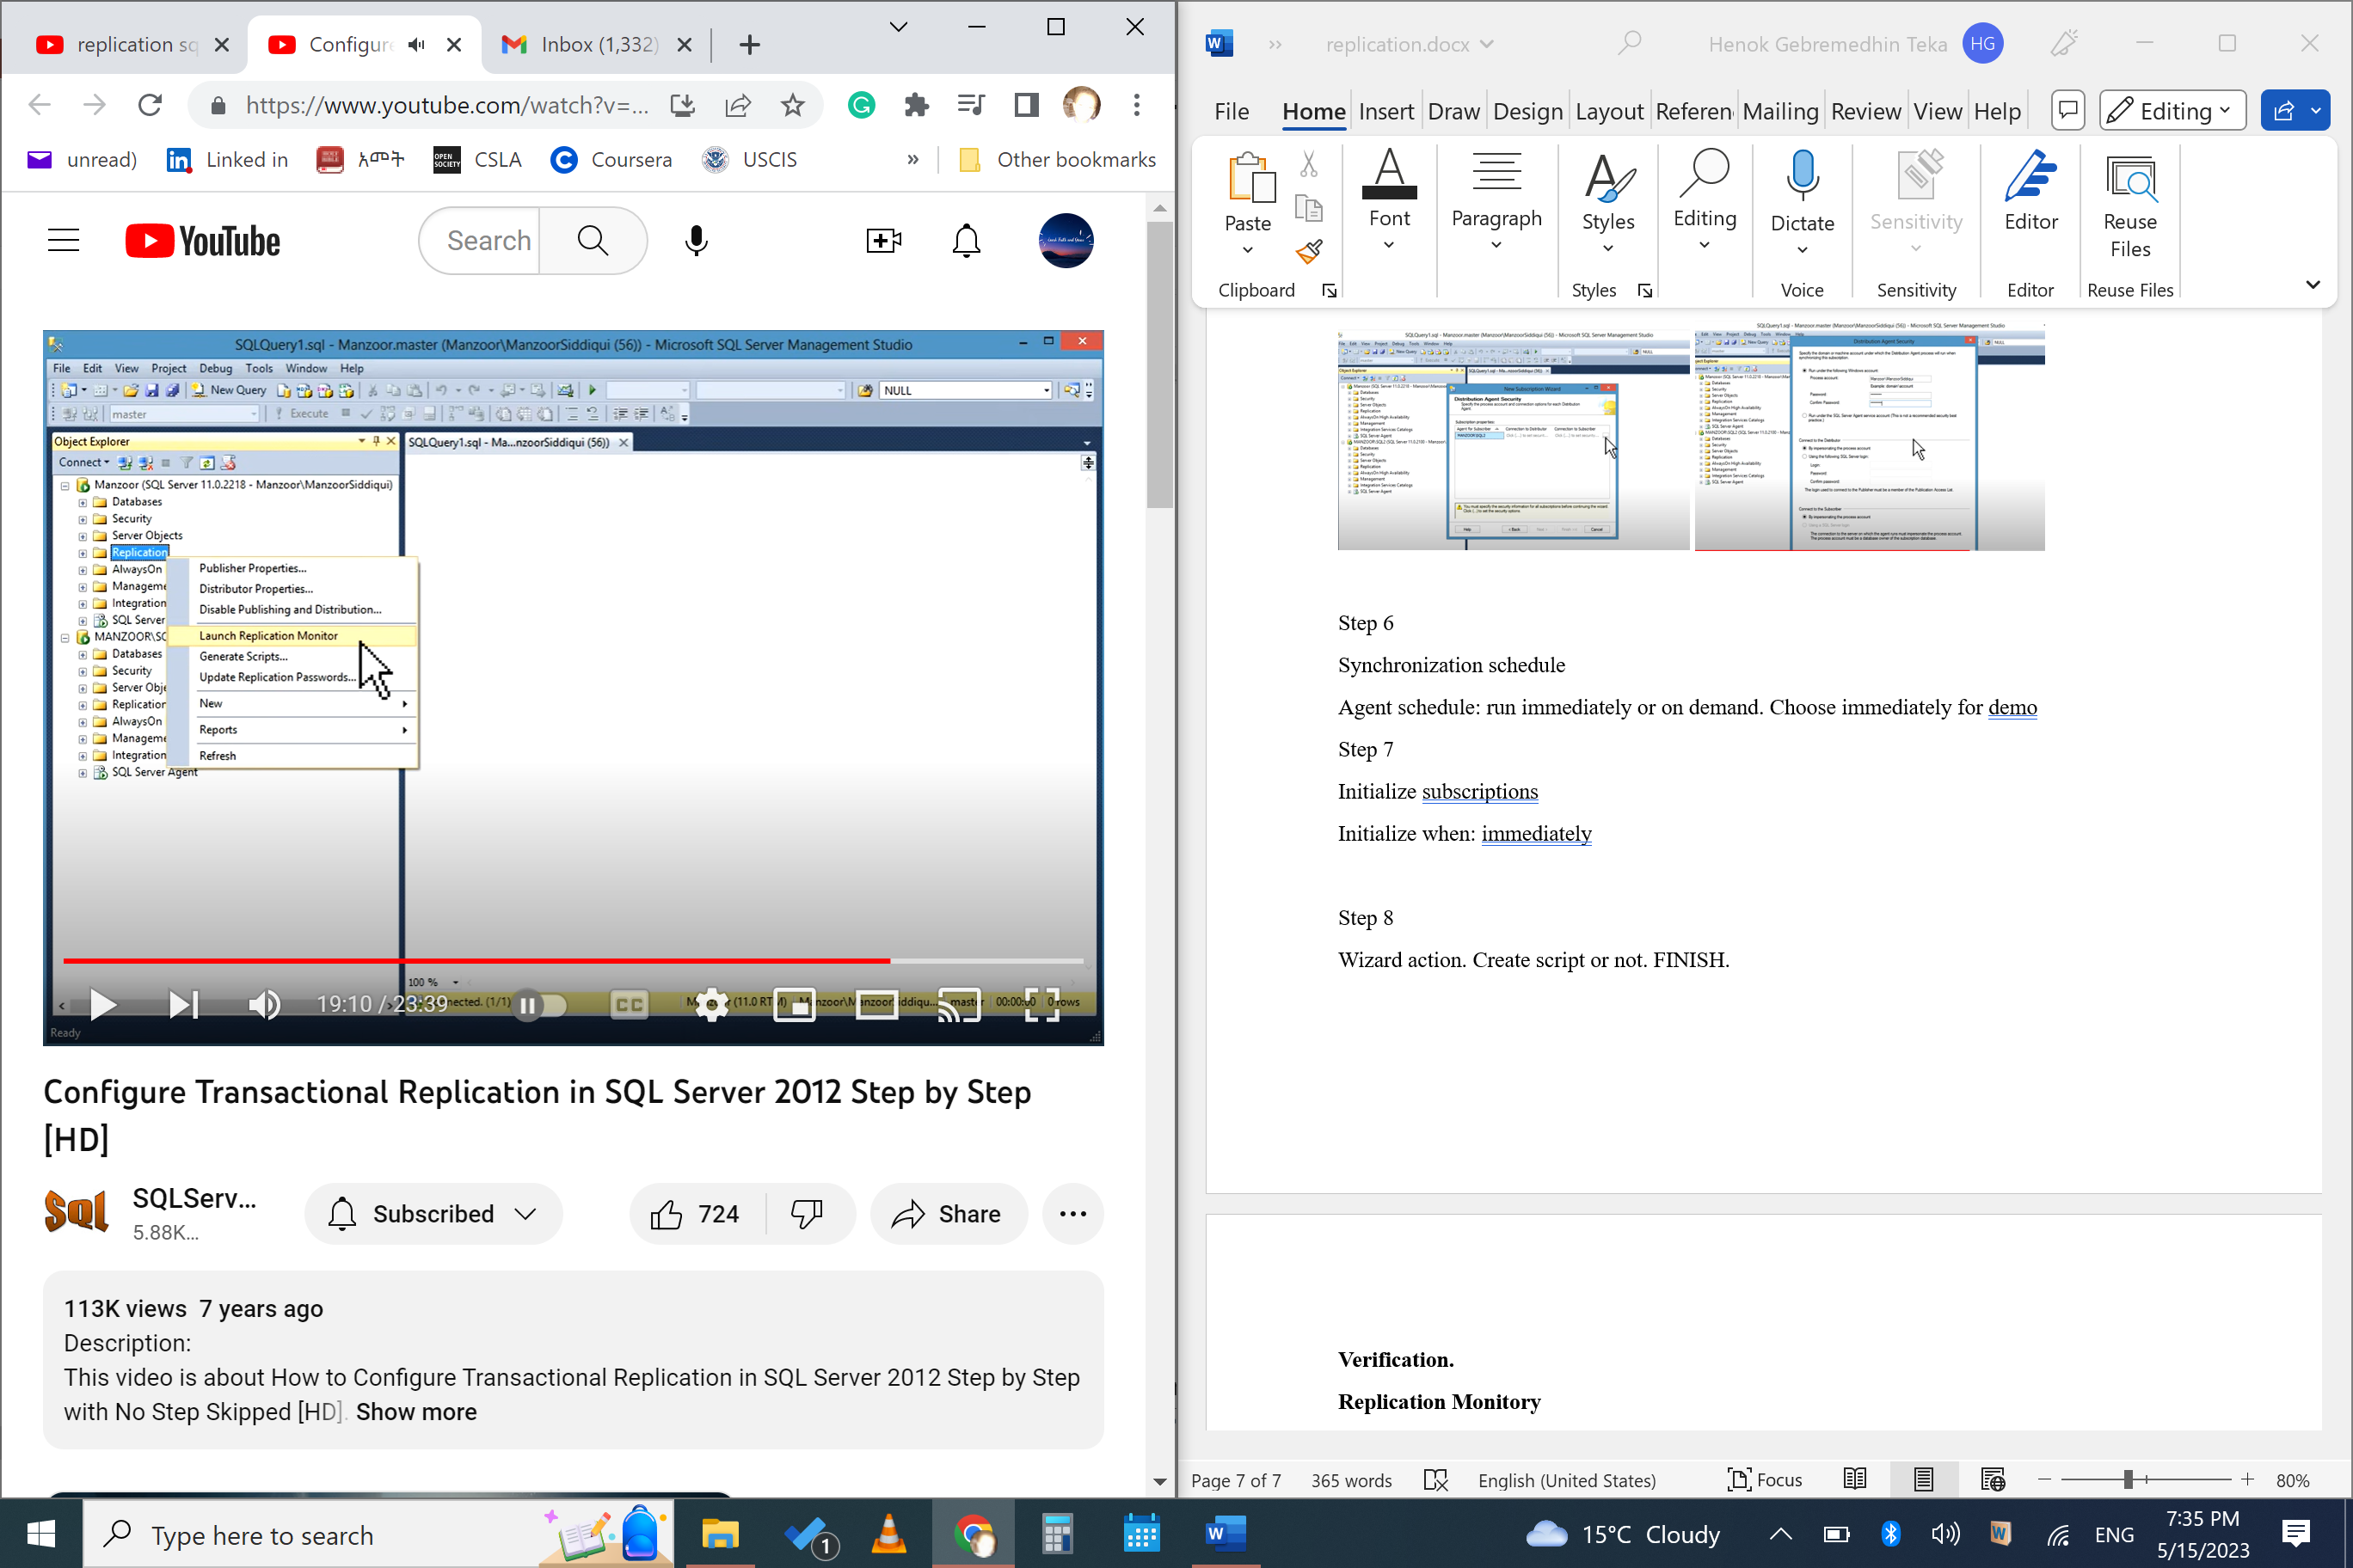

You can check the health of replication. PERFORMACE, LATENCY, OTHER LOG DETAILS.

You can select the subscriber. Performance and latency.

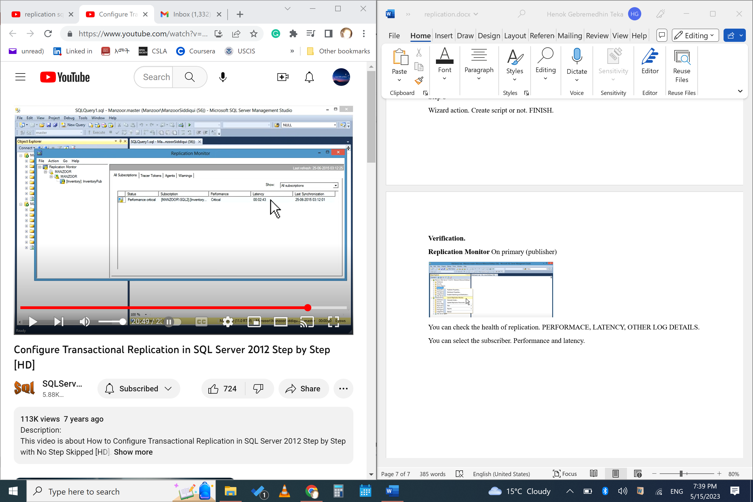

You can check by running some query like adding data and check it back.

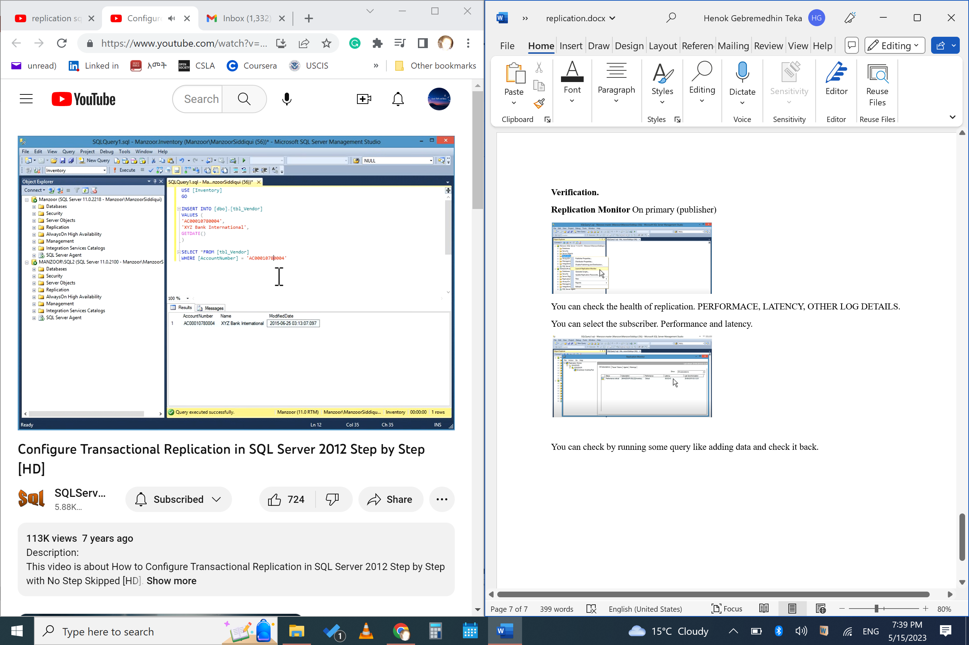

And check it on the secondary (publisher and execute select*stt above)

Check the monitor again.

Reference: <https://www.youtube.com/watch?v=rXdE9TscdpU>

Checking the replication (publication/subscription/article)

This appears on the publication server.

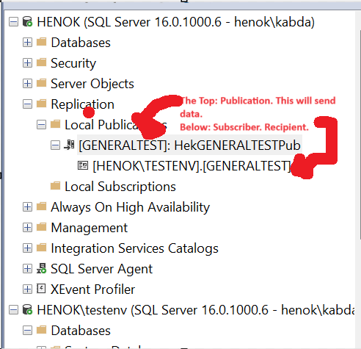

To check the **Article** (the table that is sending synching)

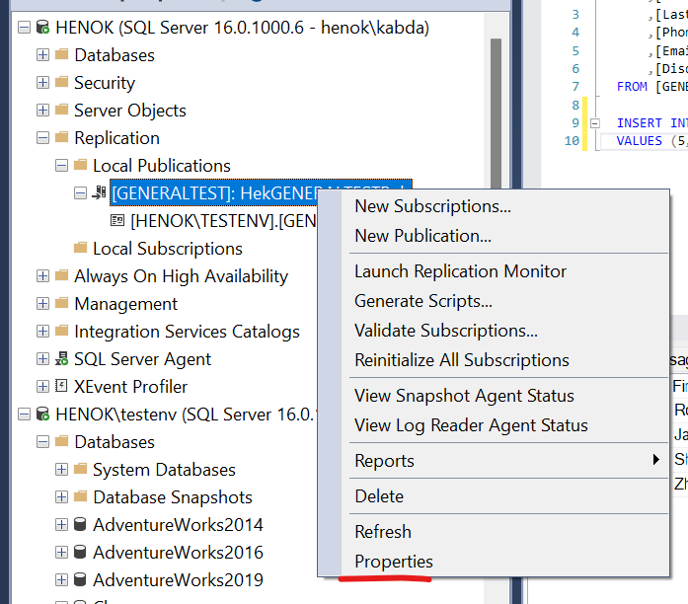 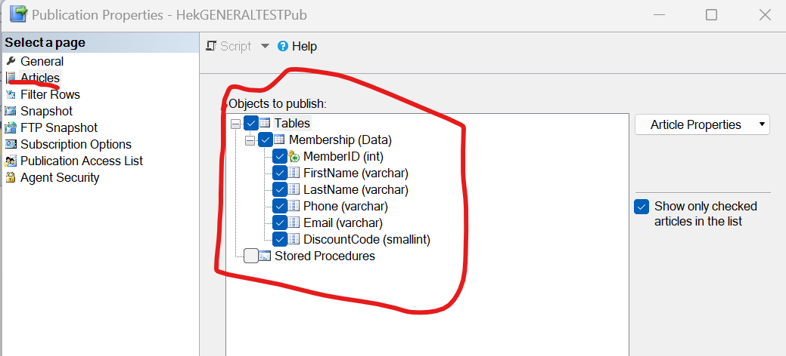

Agent job

Start this job, first time. The snapshot job will have “servername-databasename-publicationname-#”.

